

**CSE 103: Structured Programming**

**Spring 2019**

**East West University**

**Department of computer Science and Engineering**

**PROJECT**

**Online shop management software**

**SUBMITTED**

**BY**

**Md. Tohidul HaqueSagar**

**SUBMITTED**

**TO**

**Dr. Ahmed Wasif Reza**

**Chairperson**

**Department of Computer Science and Engineering**

**East West University**

**CSE103 – Structured Programming**

**Project Evaluation Rubrics**

|  |  |  |  |  |
| --- | --- | --- | --- | --- |
|  |  | **Max.** |  | **Awarded** |
|  | |  |  |  |
| **A. Report** | |  |  |  |
|  |  |  |  |  |
| **i.** | **Introduction / Problem statement** |  |  |  |
|  |  |  |  |  |
| **iv.** | **System Design** |  |  |  |
|  |  |  |  |  |
| **v.** | **Program output (Screen shots)** |  |  |  |
|  |  |  |  |  |
| **vi.** | **Source code** |  |  |  |
|  | |  |  |  |
| **vii. Disk/CD neatly attached (Y/N)** | |  |  |  |
|  | |  |  |  |
|  | |  |  |  |
| **B. Source Code** | |  |  |  |
|  |  |  |  |  |
| **i.** | **Style** |  |  |  |
|  |  |  |  |  |
|  | **Indentation** |  |  |  |
|  |  |  |  |  |
|  | **Self-documentation** |  |  |  |
|  |  |  |  |  |
| **ii.** | **Modularity (small size functions)** |  |  |  |
|  |  |  |  |  |
| **iii.** | **Error reporting capabilities** |  |  |  |
|  |  |  |  |  |
| **iv.** | **Code efficiency, strategy, and originality** |  |  |  |
|  | |  |  |  |
|  | |  |  |  |
| **C. Program Execution** | |  |  |  |
|  |  |  |  |  |
| **i.** | **Compile without errors** |  |  |  |
|  |  |  |  |  |
| **ii.** | **User friendly** |  |  |  |
|  |  |  |  |  |
| **iii.** | **Error free during runtime** |  |  |  |
|  |  |  |  |  |
| **iv.** | **Program output** |  |  |  |
|  | |  |  |  |
|  | |  |  |  |
| **D. Presentation and Demonstration [Psychomotor Domain]** | |  |  |  |
|  | |  |  |  |
| **i. Presentation and communication skills (Soft skill)** | |  |  |  |
|  | |  |  |  |
|  | |  |  |  |
| **E. Bonus** | |  |  |  |
|  |  |  |  |  |
| **i.** | **Extra significant features** |  |  |  |
|  |  |  |  |  |
|  | **TOTAL** |  | **11** |  |
|  |  |  |  |  |

**CSE103 – Structured Programming**

**Project Declaration**

**(Student 1)**

**Student ID 2019-1-60-156**

**Name Md. Tohidul Haque Sagar**

**Session 02**

**Project No. 11**

**Date submitted 09/12/19**

**Deadline of the project 09/12/19**

**My contribution in doing this**

**project (in percentage) in the group 50%**

**Description of my contribution in this shoes sector, mobile sector, man cloth section,**

**Project in the group frozen food sector,** **perfume sector, log in**

**and registration system sector, cart sector, bill**

**Part, vat ,tax, discount and over all full code**

**Number of hours I spent in doing this 40+ hours**

**Project**

**We hereby certify that this project represents the work done by all our group members with our contribution clearly stated above without copying from any other resources. We declare that no part of our work has been copied from or by other groups, and that no collusion has taken place with any other persons or groups.**

**We certify that any disks submitted with this project have been virus checked and have no viruses on them.**

(1) Signature: …………………………… Date: ........................................

INTRODUCTION

**Online shop management software**

**In this project you will make a software for online shop. The software you will develop will have two types of user namely Old customer (log in)and new customer(registration).Every Member can add products detail (product id, name, price, quantity etc.) by login to their account using their email and password. On the other hand the customers can buy those products. Member able to generate payment receipt for every time. Products’ quantity should be decreased if customers buy from the shop and quantity should be increased if register member want add more quantity to that product using its product id. Add more features to make this project more usable and intuitive. Every old member have a bank details. They can buy product using by their account balance.**

**FLOW CHART**

**Showing total cost and bank balance**

**Checking user new information**

**Checking user information password and user id**

**If old member than log in**

**If new member than ,need to registration**

**Asked**

**Old member or**

**New member**

**Calculate the price and adding vat**

I**nput option for product category**

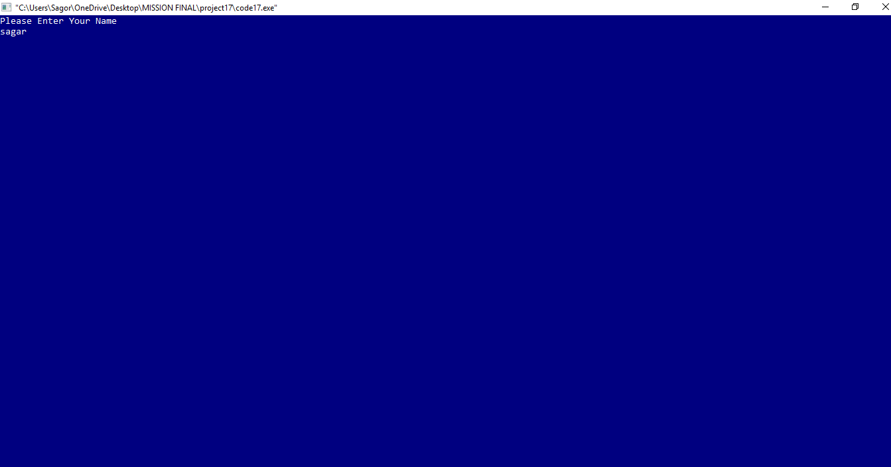

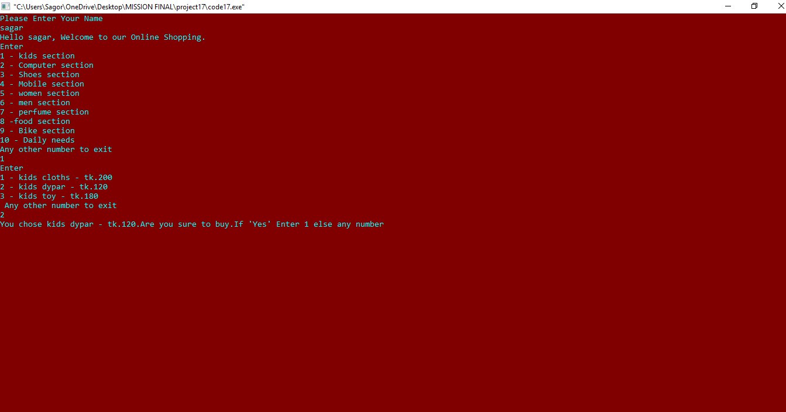

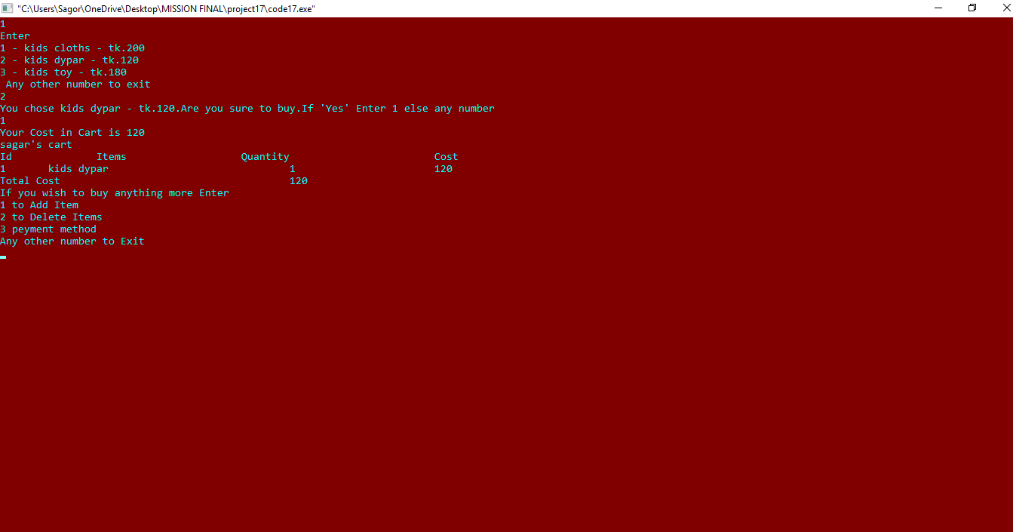

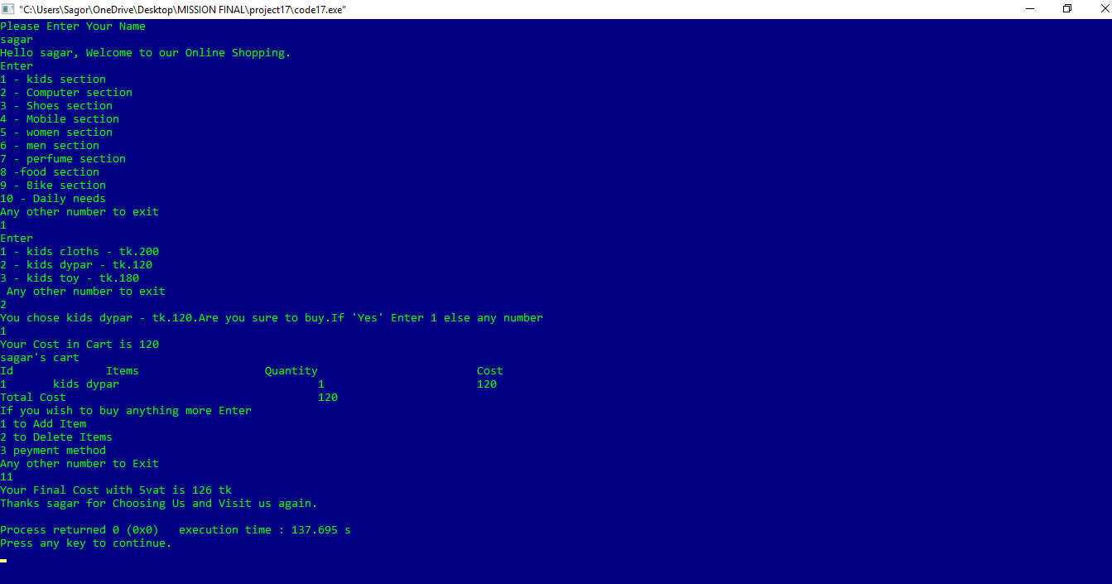

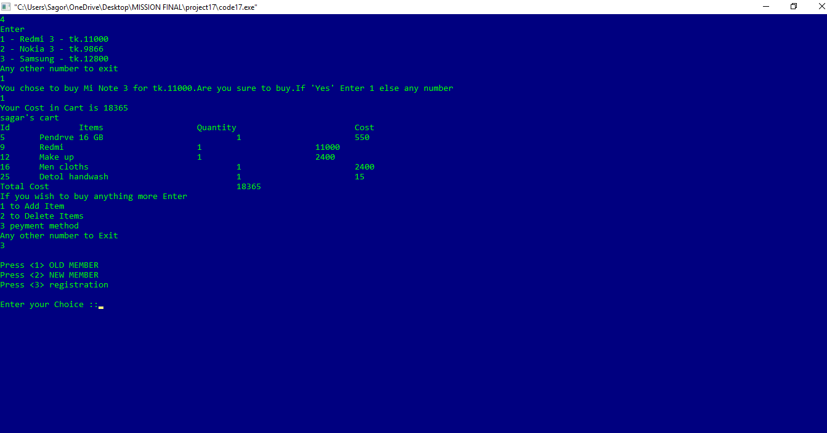

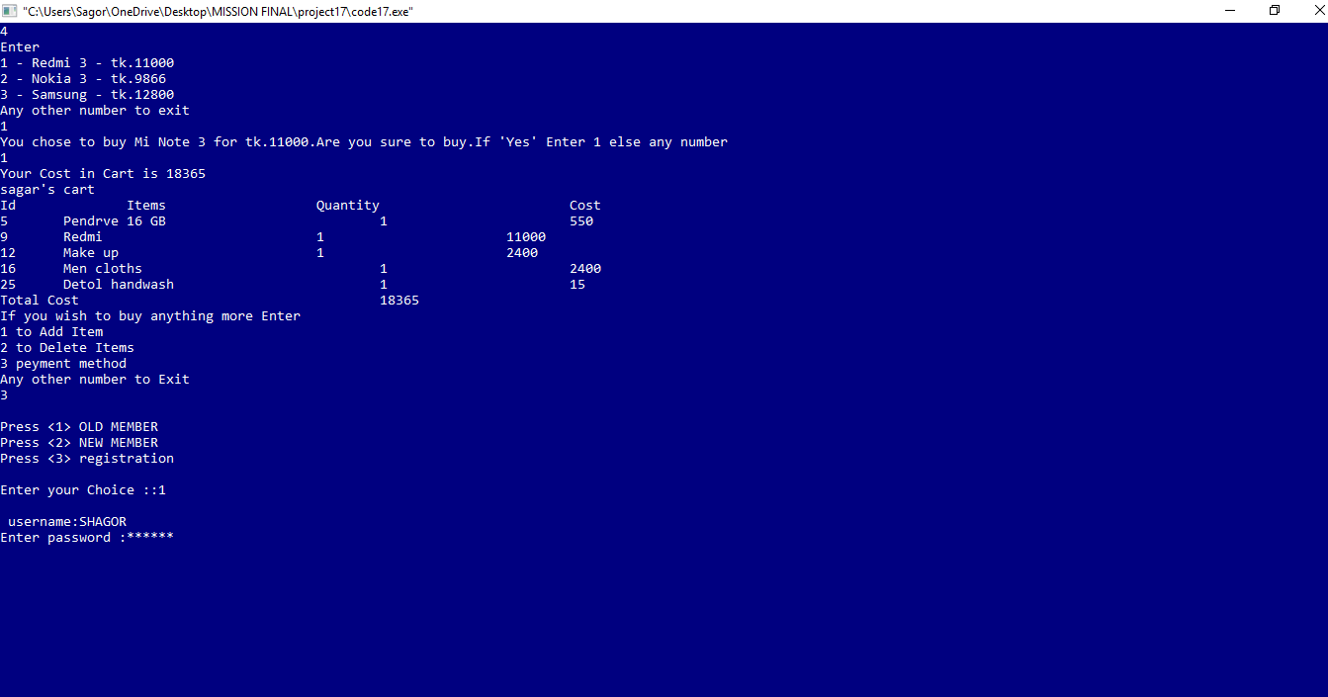

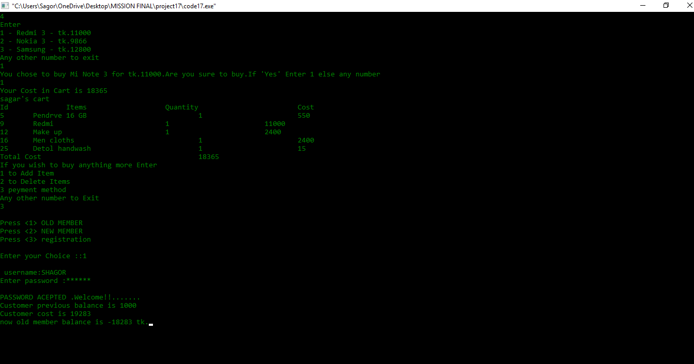

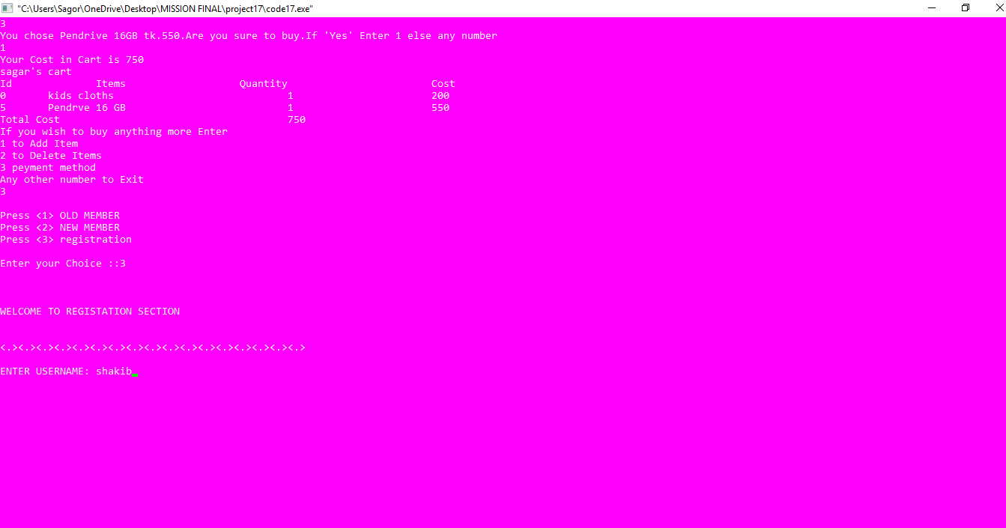

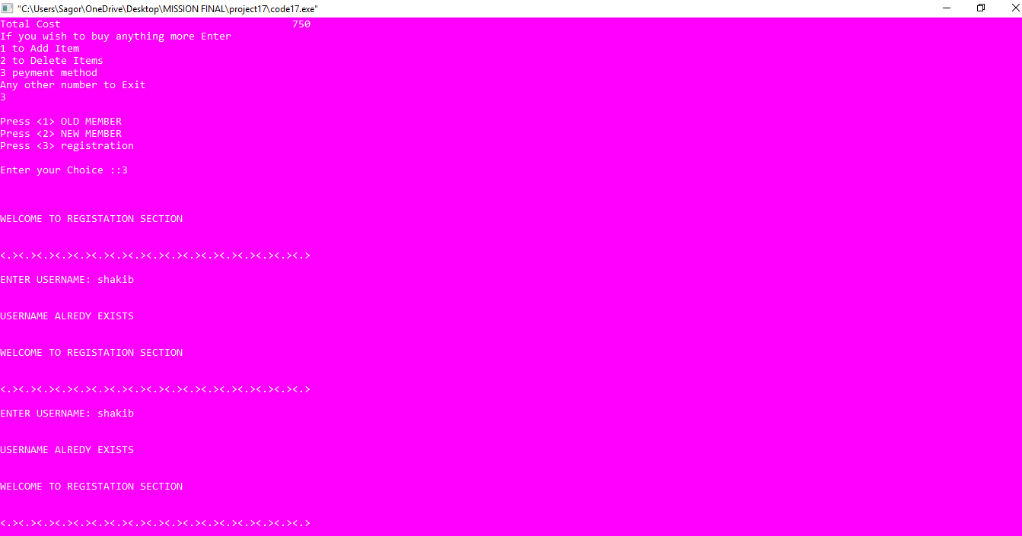

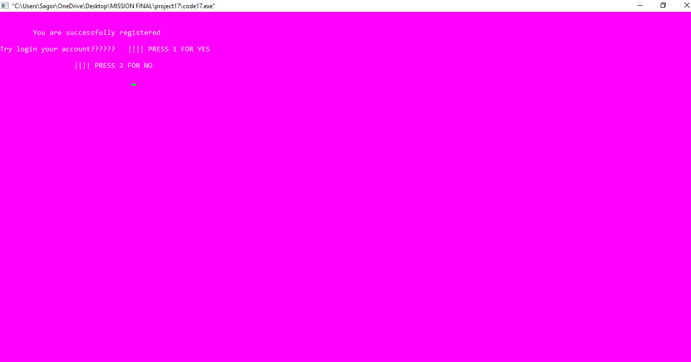

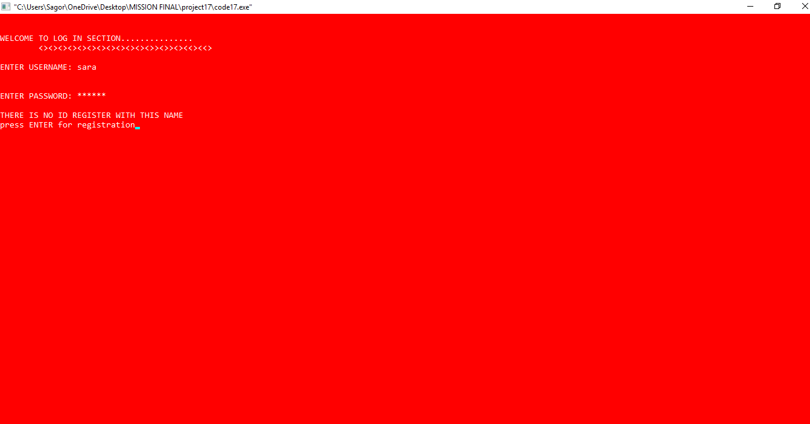

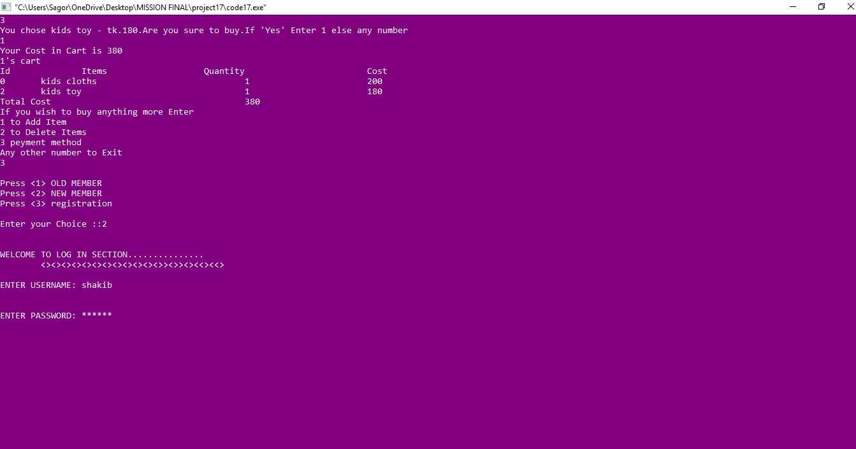

Limitations

* If we used GUI /HTML/CSS/JAVA SCRIPT /PHP LARAVEL then it would be more user friendly. As it is a terminal program the user experience will not be that much good.
* We cannot add admin option to add or delete product. (Because of our project Sumiton date was reduce)

Extra Features

* All the conversions are recorded in a history file.
* Old member can add features to the program by using member log in option.
* New member can registration and then log in.
* We add vat /tax, provide offer and membership option.
* As the program is very flexible it can be developed farther more.
* Used - do…while, struture, file, function, 2d array and try to use everything learned in this course.
* Used new colours.
* Used product id to add or delete from cart .

Conclusion

Online shop is a very handy tool in our day to day life. As our online shopping software can be easily developed it can be used as a regular application.